St Lucia Tour Report: 14th July to 29th July 2017

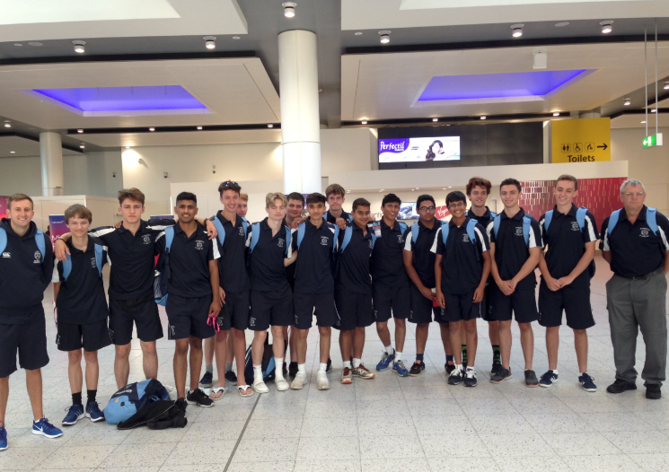
After months of preparation and training, the day of departure finally arrived, with 16 excited boys and 2 equally excited teachers ready to go at 6am in Gatwick Airport. Our suitcases and cricket bags, kindly provided by the Old Redingensians, had already been checked in so all that was left to do was to pass through security. Just a couple of hours later, our gate was called and we boarded our Virgin flight over to St Lucia. After a number of films and a fair bit of sleep, the island of St Lucia finally came into sight - we had made it! The plane touched down at Hewanorra Airport and the doors to the island were opened.

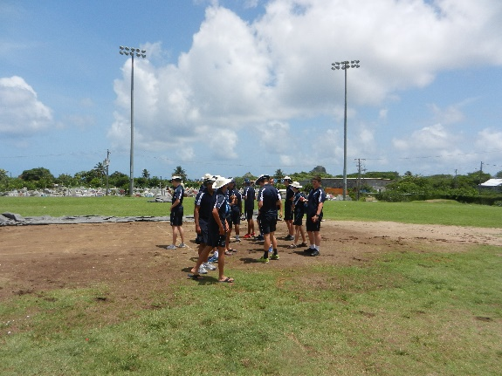
An early night later and our first match day beckoned. With overnight rain delaying the start, the team took advantage of the hotel pools and decided to do catching practice. There were two separate games, with some stunning catches, especially from Tim Cato, although they were not enough to beat the safe hands of Arjun Mathur and the tactful play of Will Clennell. In the afternoon, it was then a short journey to Gros Islet and it was clear as to why the game had been delayed: the wicket was very wet. Lunch was taken before the game, before John Eugene Academy won the toss and elected to field. Reading struggled to find their feet as they stumbled to 28-4, with the pace and stickiness of the wicket deceiving our batsmen. However, an excellent 5th wicket partnership of 80 between Arjun Mathur at 4 and Adit Rajeev at 6 lasted until Mathur was caught on 34. Adit managed to battle on, scoring an impressive 60, with the team finishing on 145 from 35 overs.

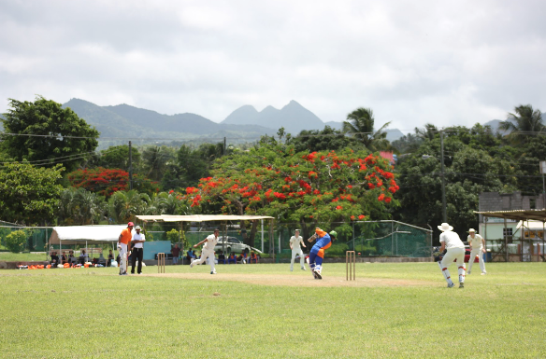
The bowlers went out to the field, not knowing what was to come. It started off promisingly after Mark Cobb struck twice early on, reducing the opposition to 24-2. However, further wickets were hard to come by, with Reading only managing to take 4 wickets in total, a third for Cobb and one for Andrew Prowse. Ultimately, John Eugene Academy chased the score down with 12.5 overs to spare, as Reading slumped to a 6-wicket defeat. Once back at the complex, the team enjoyed a Caribbean barbeque at the Bay Gardens Resort, before settling down to prepare for the match the following day.

Choiseul, back down in the south of the island, were to be our next opponents. The journeys to and from the venue were our worst of the whole tour, with two broken down buses, and some rather repetitive Country & Western music.
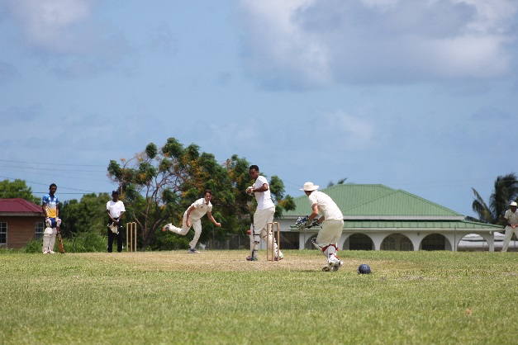
At the game itself we lost the toss, and with stiff legs from the long journey we were put out to field. Our bowlers performed well with Josh Wallace picking up four wickets and Prowse getting three. Choiseul were all out for 176 and with that we headed into the local school for lunch. Going out to bat we were eager to come back from our loss in the first game, however wickets fell quickly right from the start of our innings, and by the time we reached 80 runs we had been bowled out. A disappointing performance, however it was another fantastic game of cricket in an absolutely incredible area of St Lucia, so it was hard to be too upset.

Our next two days were an opportunity to rest and enjoy the traditions of St Lucia, starting with the annual carnival in Castries. We arrived in Castries close to midday, when the heat from the Sun was almost at its strongest and the temperature sat around the 30°C mark. At the carnival, the highway is closed to public access and instead served as a path for the tens of thousands of colourfully dressed dancers and the extremely loud music trucks to slowly move along on their way to the main dance stage. We stood on the edge of the railing for at least an hour watching the endless flow of people and music moving along the highway and occasionally getting to speak to one of the dancers themselves and learning how kind and welcoming the locals are. Meanwhile, the following day we were able to use the resort’s new Splash Island water park, before returning to the hotel to watch a passing Caribbean storm from the comfort of our rooms.

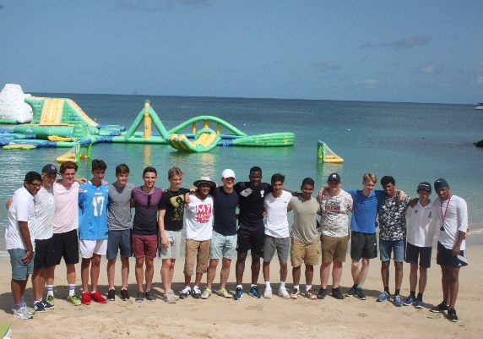
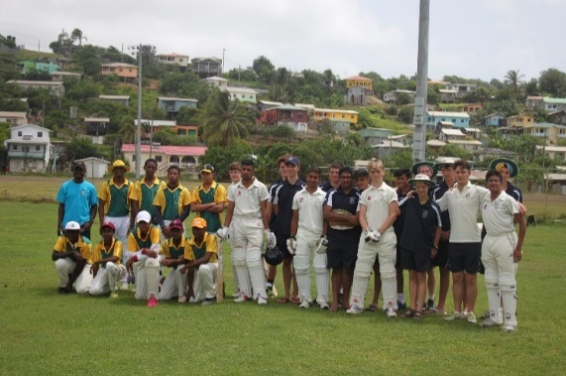
Keen to get our first win on the board, we got a shock on arrival at the Dennery ground. The pitch was very worn in the outfield and there didn’t seem to be a groundsman, with only some free roaming goats to keep the grass from growing too long. Reading won the toss and elected to bat first. Despite suffering two early wickets, Tim Cato and our lower order batsmen helped Reading to post a respectable score on the board. Jain (31) and Cato (27) were the two top scorers. The Dennery innings got off to an explosive start and from an early stage it was clear to see that they had a couple of batsmen who weren’t afraid to hit bowlers back over their heads. However, the Reading School fielding in this game was extremely efficient and saw almost no fielding errors for the whole innings. Bowlers Mark Cobb and Arjun Mathur secured vital early wickets in the Dennery innings and Adit Rajeev swept up the middle and lower order, finishing with 5 wickets. A first victory for the touring side!

With a trip to Pigeon Island followed by a T20 under lights planned, we set off to the beach, where we had a surprise guest. Bay Gardens Resort manager Miss Patrick had arranged a visit from ex West Indies Captain and 2-time World Cup winner Darren Sammy! In what is without doubt one of the highlights of the entire tour he spoke to us about his story and journey in being the first St. Lucian to play international cricket, before posing for some memorable pictures on the beach with each team member. What a start to the day!

After that incredible start, our water taxi arrived and we all got on to ride it across to Pigeon Island. After a tough hike up to the top of the peninsula we were treated with a view that was well worth the effort. The peninsula, which was a crucial vantage point in the Franco-Anglo wars over St. Lucia, gifted a view of neighbouring island Martinique and across the whole of Rodney Bay. After lunch and a bit of a rest it was time to collect our kit and catch the bus off to the Gros Islet cricket ground.

With the lights flickering into action, skipper Arjun Mathur won the toss and elected to bat first. Ed Denman (59 off 33) and Adit Rajeev (76 off 56) shared a partnership of 108, helping Reading to a score of 181-3 off 20 overs. There was some big hitting especially from Ed Denman who hit one memorable 6 into the graveyard at cow corner. A stunned John Eugene Academy came off the pitch with little chance of victory in sight.
And that’s the way it remained for much of the second innings as early economical bowling from Mark Cobb and Arjun Mathur quickly meant the required run rate was higher than 11 runs an over soon enough. Some late hitting got John Eugene to 150 at the end of 20 overs, however, the match always felt in the bag following the fantastic batting display. A fantastic victory to round off a fantastic day!

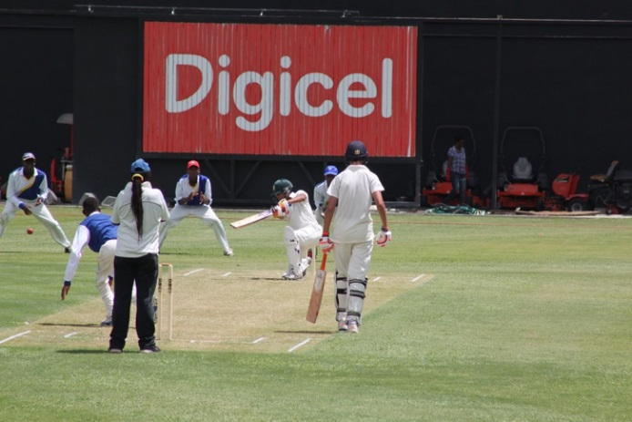
Day nine saw Reading Boys play their first match at the Darren Sammy National Stadium and excitement ran high amongst the squad. After an early breakfast, the team boarded the bus to face John Eugene for the third time on tour with the series level at 1-1. Reading were put into bat on what looked like the best wicket they had seen yet and openers Josh Wallace and Ragan Jain looked to go out and score runs. However, Jain fell early for just 4 on a wicket that was causing some trouble. It took a slow and steady recovery from Wallace and new man Adit Rajeev to put Reading back on top, but despite this, Reading Boys ending up all out for just 96 in 29.3 overs.

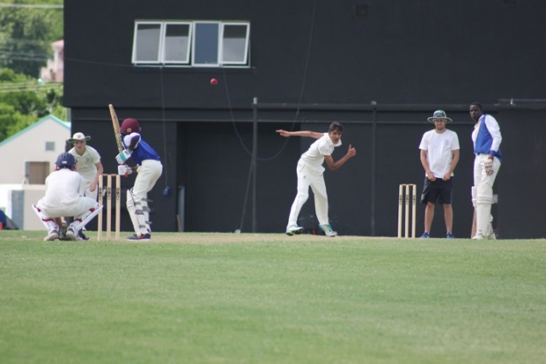
After a fiery team talk during the break from Mr Walder, the team came out with steely determination to defend what seemed to be an under-par score on the pitch. Mark Cobb and Arjun Mathur opened the bowling for Reading and both struck in their first overs, leaving John Eugene at 0-2 after 2 overs. Both Cobb and Mathur kept the pressure up and by the end of the tenth over Cobb had picked up numbers 4 and 5. With the score at 11-4 after 10, John Eugene went on to score just 56 all out. Reading had won by 40 runs in an incredible bowling performance from all 5 bowlers with Cobb and Asghar taking the wickets while Mathur, Wallace and Saket Koti bowled tight lines to keep the pressure on the batsmen.
With one game abandoned, we had another fixture arranged against Dennery, and on arriving at the ground it was clear that the seaside town had been void of much rain, and the wicket was a perfect batting track. Nevertheless, skipper Andrew Prowse failed to win the toss and Dennery elected to bat first, on a surface that would surely crumble later as the game progressed. Saket Koti and Josh Wallace were the pick of the bowlers, with Koti taking 1 and Wallace 3 much to the dismay of the out and out bowlers on tour, and a great all-round performance by the team meant that Dennery finished on 158 all out in 24.3. A fast opening partnership of 60 from Denman (34) and Wallace (13) then put Reading in a strong position, yet a quick flurry of wickets from some poor shots left Reading on 119-7 with overs to spare. A vital innings from Rajeev (30) looked to bring Reading back into a winnable position, yet he was caught off a poor ball. In a throwback to Shiplake earlier in the year Prowse and Blake played a defensive partnership looking to use the overs and took Reading to 158, level with the 1st innings with 9 balls to spare. That was until Prowse patted one back to silly mid-off from the spinner. In came Cobb to save the captain’s blushes once again, squirming the ball away to point and scampering through to win a game which had turned out much trickier than it should have. Revitalised by their 4th win on the trot the boys hopped back on the bus for an evening swim and dinner in Rodney Bay.

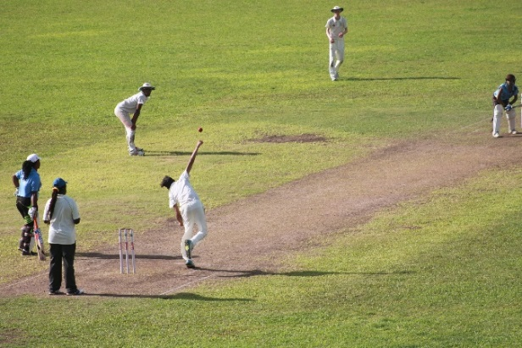
Our penultimate opponents were the St Lucian Ladies National Team. Played at the Mindoo Philipp Ground, captain Andrew Prowse won the toss and sensibly decided to bat first. In a rain-effected match, and despite the early wicket of Ragan Jain, his opening partner Josh Wallace remained consumed to bat around the rest of the order. Reading School finished on a total of 159-6 from 35 overs, which could prove tough to defend. With bowlers Mark Cobb and Arjun Mathur missing it was up to seamers Andrew Prowse and Saket Koti to step up, which they did superbly. Both bowled tight lines and lengths, with the opposition scoring a mere 21 from the first 11 overs. The St Lucian women eventually finished on 97 all out following yet another top-class bowling display from Reading School, giving us a 64-run victory.

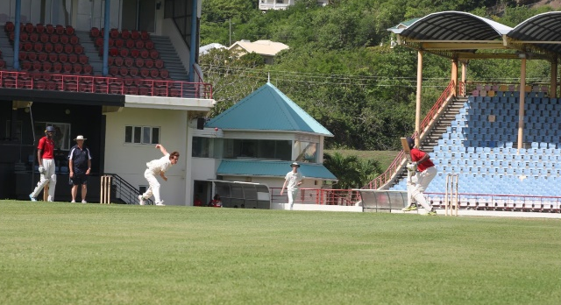
Our final match took place at the Darren Sammy Stadium. A 35 over match was decided, with Northern Grassroots winning the toss and deciding to bat. In the very first over of the match, Mark Cobb bowled an unplayable delivery to dismiss their opener for a second ball duck. The pressure was now placed heavily on the batting side, but even though early wickets had been taken, the Grassroots Academy were scoring at nearly a run-a-ball, being 33-3 after only 6 overs. After the 21st over, Northern Grassroots were 87-7, but a valiant display of tail-end batting saw Grassroots Academy reach a total of 121 all out, with Joshua Wallace taking the final wicket in the 32nd over. We had a total of 122 to chase and were confident in doing so, having chased down 155 against Dennery two days ago. Unfortunately, we were unable to battle against the strong bowling attack of the Northern Grassroots and we were bowled out for 99. Doubt crept into us as soon as we saw the top run scorer on tour, Adit Rajeev, dismissed for a golden duck! Overall, however, 5 tour wins was something to be proud of.
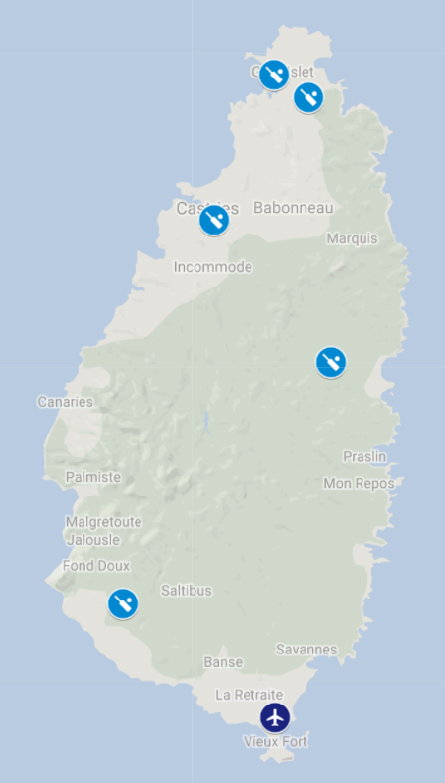
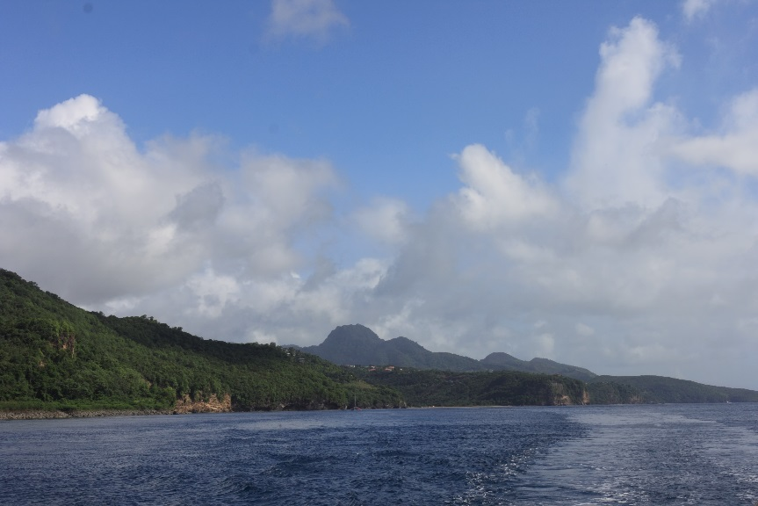
On a last full day of the tour, we had a catamaran cruise, which proved to be the highlight of our trip. We set off pretty early in the morning, reaching the St Lucian harbour in time for a 9am departure. With a combination of loud music, sunbathing, waterfalls, sugar cane, snorkelling… the list could go on, it was an excellent conclusion to our tour. That evening we had our award ceremony, with Adit Rajeev taking some of the main prizes, while the team also thanked everyone who helped make our trip so special, including Mr Bellinger, Mr Walder and Roland Cox, in addition to two locals, Natasha and “Uncle Vaughan”, who helped us make the most out of every day on tour.

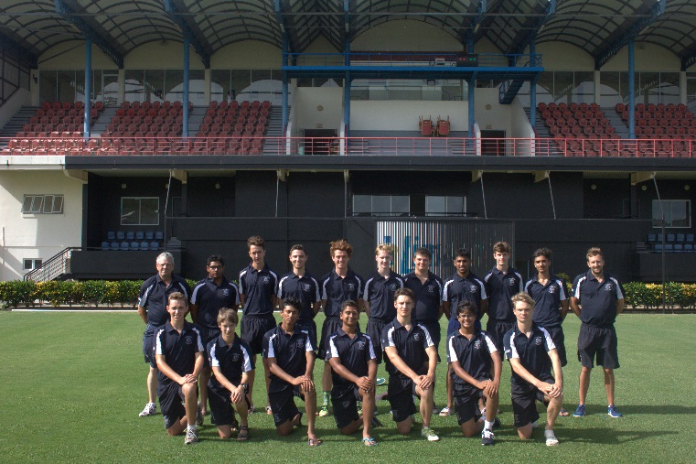
With the airport beckoning, we took advantage of one last hour at Splash Island, before waving goodbye to the excellent staff at the Bay Gardens Hotel. Listening to popular tunes “Sully” and “Sweet St. Lucia” one more time, we got the plane back home and returned to Gatwick Airport bright and early on Saturday morning. It was an exceptional experience for everyone on tour, and would not have been possible without the work of all the staff, Miss Patrick at the resort for the Darren Sammy visit and barbeque meal, as well as the support of the Old Redingensians and the Reading Foundation – hopefully we will be able to put this opportunity into practice next year when the cricket season comes back round again!

